**IT-314 SEN PROJECT**

**Instructor: Prof. Minal Bhise**

**FINAL REPORT**

**Group Members:**

**Aditi Sogra 201501131**

**Drashti Lukhi 201501182**

**LINK OF CODE:**

Code includes java source files, class files and the libraries which are required.

<https://drive.google.com/drive/u/0/folders/1DwWshRXdTnlcwFxxb8sTTm_Rl2zOqcX7>

**SCREENSHOTS OF THE OUTPUT:**

1. **Registration:**

* Registration via Email:

Table before Registration:

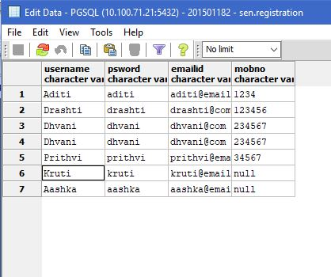

Registration via email is selected. So user has to enter his email id, username and password. After that the registration link is sent to email. If the correct link is entered then registration is successful.

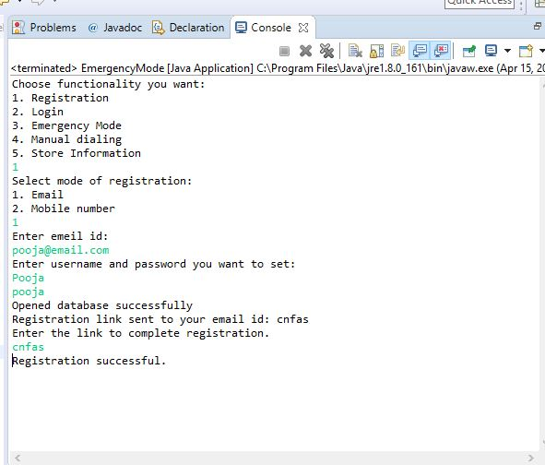

After successful registration, new entry is made in the table. In case of registration via email, mobile number is not entered so that entry in the database is null.

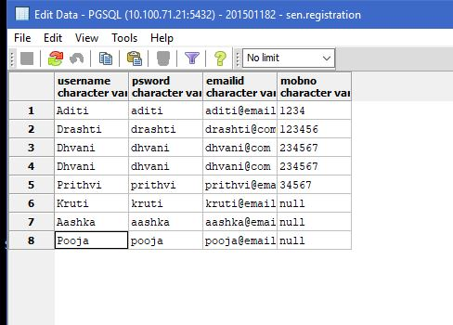

* Registration via mobile number:

Database table before implementing registration.

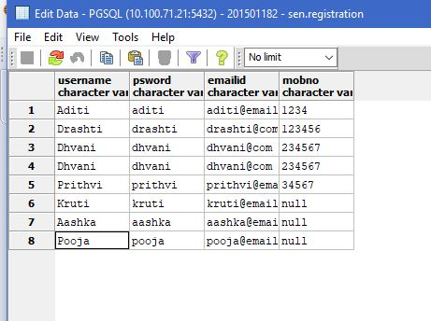

Mode of registration selected is mobile number. So mobile number, username and password are entered. OTP is sent to mobile number, if correct OTP is entered the registration is successful and new entry is made in the database.

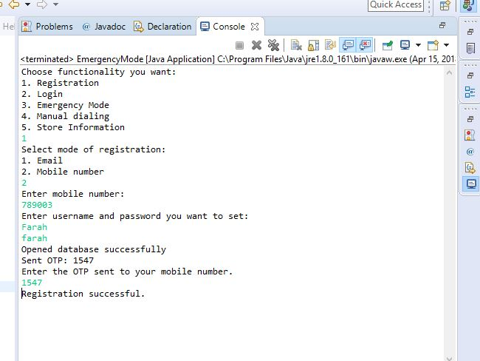

Database table after successful implementation of registration via mobile number. In this case registration is done via mobile number, so email id is not entered. Hence, that value is null.

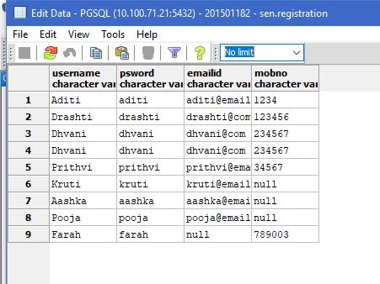

**2. Login**

Login option is selected. Then username and password are then entered. If the username and password are matched then login is successful.

* Successful Log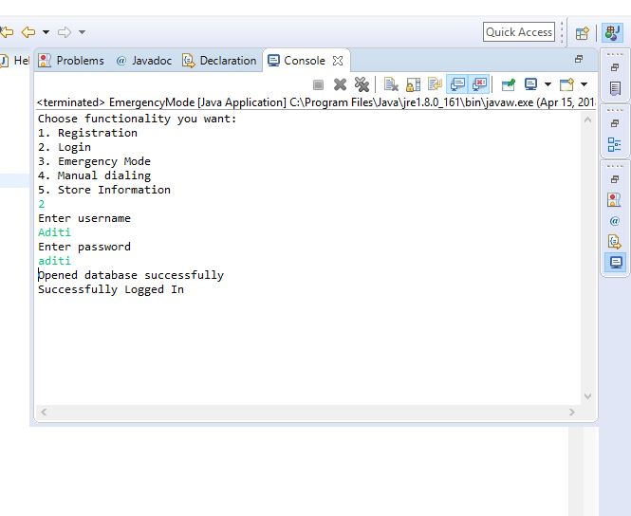
* Unsuccessful Login

In this case the password entered does not match with the password corresponding to that username. So login is unsuccessful.

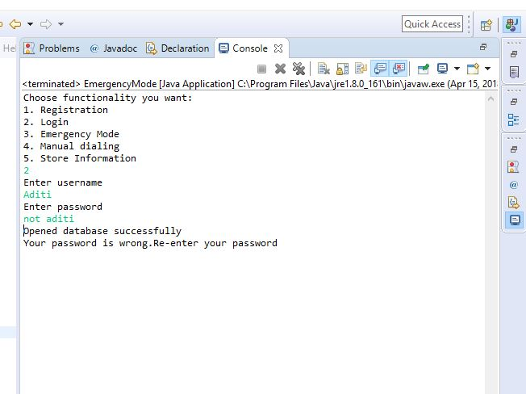

**3. Emergency mode**

User selects emergency mode option that is panic button is pressed. After that an OTP is sent on the mobile, if the user enters the correct OTP that means user has pressed the panic button accidentally. But if no OTP is entered or wrong OTP is entered then emergency is confirmed and the device will start capturing GPS location and photos. Using the location captured, the system will search for the hospital in that area from the database. After that call is made to that hospital.

SMS is sent to user’s family members. Highest priority mobile number is selected from the database and SMS is sent to that family member.

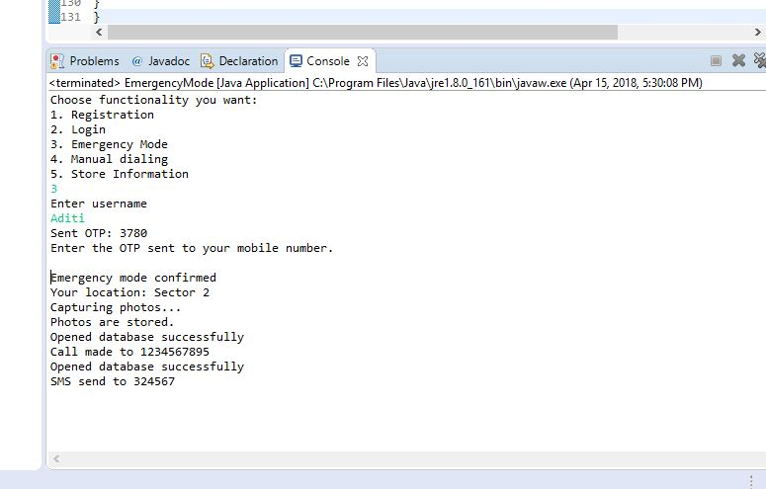

Emergency contact list table:

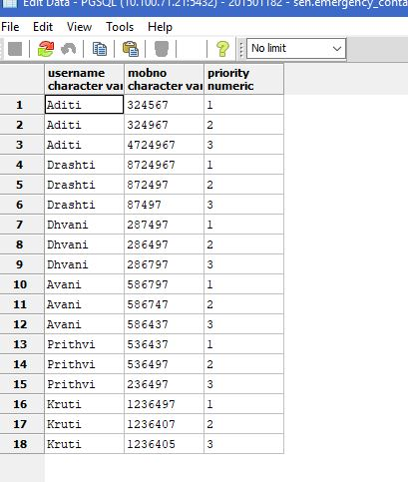

Correct OTP is entered. So no emergency.

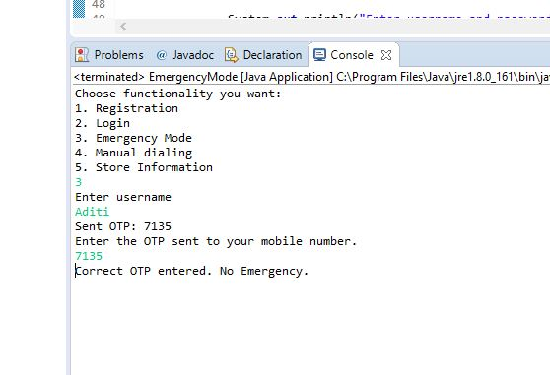

**4. Manual Dialing**

Manual dial option is selected. That means user wants to contact the help centre himself/herself.

* User type Myself

After selecting that, user selects ‘myself’ that is he wants the emergency service for himself. So his GPS location is scanned. Then user selects fire brigade, so in database the fire brigade near to user’s location is selected and the details are displayed.

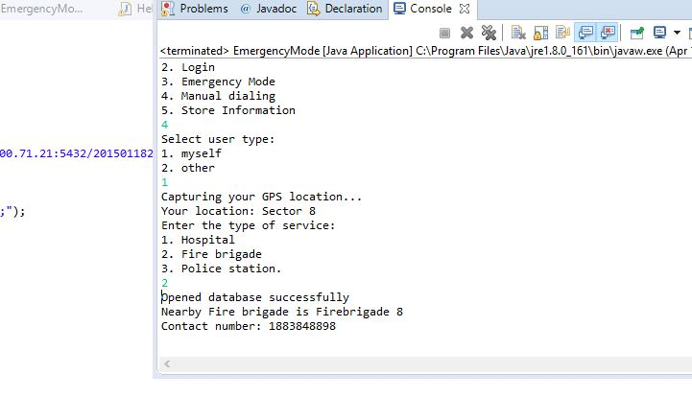

When Police station is selected:

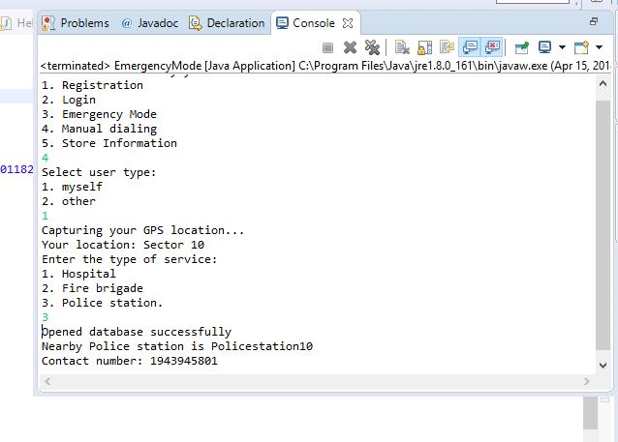

* User type Other

When user selects ‘other’, that is he wants the emergency service for someone else. So the address where the service is needed should be entered. After entering the address, service type is entered as before. The the help centre nearby to the location entered is returned.

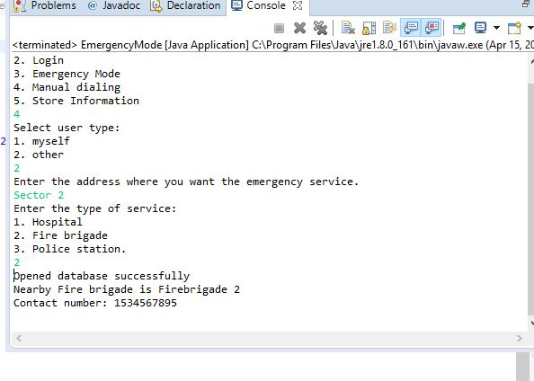

When police station is selected after selecting the other option:

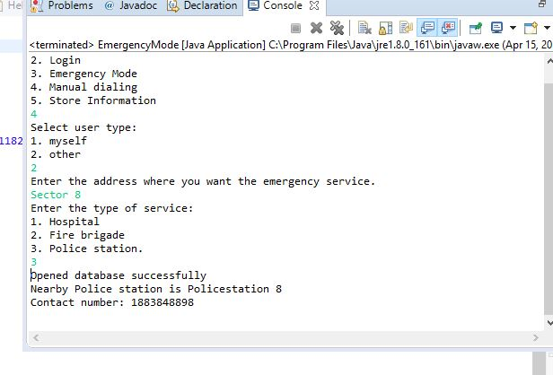

Table showing help centres and their contact number in each area.

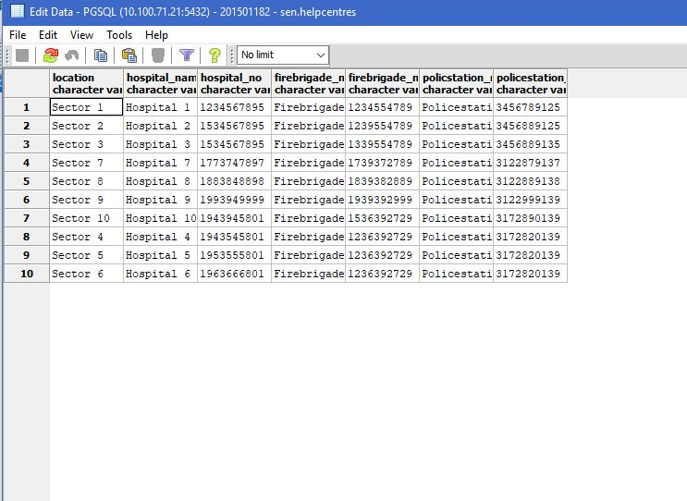

**5. Store Information**

This functionality is to store user information like blood group and other health problems.

Table before implementing this functionality.

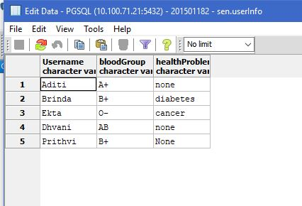

To store the information, first username is entered. Then the blood group and health problem if there is any. This information will be stored in the database.

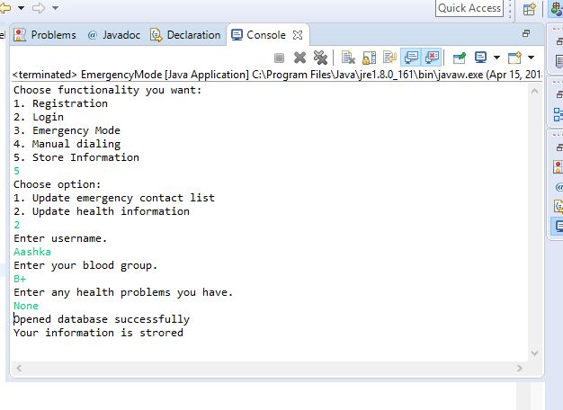

Database table after storing the information.

